Infosys Springboard Virtual Internship 6.0 Completion Report

Team Details: 1.MENTOR: SELCIYA

2.TEAM MEMBERS: Mahesh Dodlla, Pilli Maheshbabu, Shruti Jain, Harshitha, Thejaswi, Nandhini

Batch Number: 13
Start date: 02-02-2026
Names: <1.DODLLA MAHESH
2.PILLI MAHESHBABU
3.SHRUTI JAIN
4.HARSHITHA
5.THEJASWI
6.NANDHINI>
Internship Duration: 8 Weeks

1. Project Title: HotelRevAI AI Driven Revenue Analysis for Hotels.

2. Project Objective: The central objective of HotelRevAI is to develop an Artificial Intelligence-powered analytics solution that optimizes hotel revenue management. By leveraging machine learning algorithms to analyze booking data, market trends, and customer behavior, the project aims to transition hotels from static pricing models to dynamic, data-driven strategies that maximize overall profitability and operational efficiency.

Key Project Goals
To achieve this primary objective, the project focuses on several core functionalities:
- Demand Forecasting: Utilizing historical booking data and predictive modeling to accurately forecast room demand across different seasons, local events, and market conditions.
- Dynamic Pricing Optimization: Implementing algorithms that recommend real-time adjustments to room rates based on current demand, competitor pricing, and inventory availability to maximize Revenue Per Available Room (RevPAR).
- Cancellation Prediction: Developing classification models to identify the likelihood of a booking being canceled, allowing hotel management to mitigate revenue loss through strategic overbooking or targeted retention efforts.
- Customer Segmentation: Analyzing guest demographics and behavior to identify distinct customer profiles, enabling personalized marketing and tailored service offerings.

3. Project description in detail

1. Detailed Project Description
HotelRevAI is an advanced, machine learning-based analytics platform designed to revolutionize revenue management in the hospitality sector. Traditional hotel pricing relies heavily on static, seasonal rates and manual intuition, which often leads to lost revenue through underpricing during peak demand or unbooked rooms during off-peak periods.
This internship project focuses on building an intelligent system that analyzes historical booking data, market trends, and guest behavior patterns. By forecasting room demand, optimizing dynamic pricing in real-time, and predicting booking cancellations, HotelRevAI enables hotel administrators to transition from reactive pricing adjustments to proactive, data-driven revenue maximization strategies. The ultimate goal is to optimize Revenue Per Available Room (RevPAR) while maintaining high occupancy rates.
2. Approach & Methodology
The project follows a structured machine learning pipeline to ensure accurate and actionable insights:
- Data Collection & Preprocessing: The initial phase involves gathering raw historical hotel booking datasets. The data is rigorously cleaned to handle missing values, remove duplicates, and encode categorical variables (like room type, meal plan, and booking channel).
- Exploratory Data Analysis (EDA): Statistical analysis and data visualization are conducted to uncover underlying patterns, such as identifying peak booking seasons, average length of stay, and correlations between lead time and cancellation rates.
- Feature Engineering: Creating new, highly predictive variables, such as "booking window" (days between booking and arrival) and "weekend stay indicators," to improve model performance.
- Predictive Modeling: * Time-Series Forecasting: Applied to predict future daily and weekly room demand.
  - Classification Algorithms: Deployed to assign a risk probability to each booking to predict the likelihood of cancellations or no-shows.
- Evaluation & Optimization: The models are evaluated using standard metrics (Accuracy, F1-Score for classification; RMSE for forecasting) and fine-tuned through hyperparameter optimization to ensure high reliability in real-world scenarios.
3. Technology Used
To build and deploy the HotelRevAI system, a robust stack of industry-standard data science and machine learning tools is utilized:
- Software Or Tool Used: Power BI
Key Aspects of Power BI:
- Software Components: It consists of several components, including the desktop application (Power BI Desktop), SaaS service (Power BI Service), and mobile apps.
- Core Functions: It is used for data connectivity, transformation (via Power Query), modeling, and visualization.
- Capabilities: Power BI includes AI features (like Copilot), data modeling using DAX, and easy sharing through cloud services.
- Data Manipulation & Analysis: Power Query, DAX Calculations, Transformation.
- Data Visualization: Data Connectivity & Modeling, Visualization Pane, AI Visuals, Natural Language Processing(Q&A), Interactivity
- Development Environment:
Key Components of the Development Environment:
- Data Ingestion & Cleaning: Utilizing Power Query to clean historical data, handle null values in columns like ratings_given, and merge datasets.
- Data Modeling: Creating relationships between booking data, hotel types (Resort vs. City), and customer segments.
- DAX (Data Analysis Expressions): Building complex measures for key metrics such as Average Daily Rate (ADR), Revenue Per Available Room (RevPAR), Occupancy %, and Realisation %.
- AI/Visual Analytics: Implementing forecasting and demand prediction models using Python in Power BI or built-in Key Influencers visuals to identify factors affecting revenue.
- Dashboarding: Developing interactive reports with slicers for property-level breakdowns, weekday/weekend comparison, and trend analysis.
- Version Control: Git & GitHub (for maintaining project documentation and codebase)

4. Timeline Overview
Week | Activities Planned | Activities Completed
Week 1 | Data Foundation | Data sourcing, cleaning, and ETL (Extract, Transform, Load) processes.
Week 2 | Data Modeling | Defining Star Schema relationships and establishing primary/foreign keys.
Week 3 | Revenue Core | Development of DAX measures for ADR, RevPAR, and Occupancy %.
Week 4 | KPI Visualization | Building the primary Revenue and Occupancy trend dashboards.
Week 5 | Guest Insights | Implementing demographic segmentation (Age, Region, Booking Type).
Week 6 | Channel Analysis | Analyzing performance across different platforms (Direct, OTA, GDS).
Week 7 | Forecasting | Developing predictive visuals for cancellation trends and booking pace.
Week 8 | Strategy Finalization | Final Dashboard UI/UX polish and insight-driven pricing recommendations.

5a. Key Milestones
Milestone | Description | Date Achieved
Project Kickoff | 1. Project Overview  HotelRevAI is an artificial intelligence project designed to help hotels maximize their profits and improve room booking efficiency. Instead of relying on traditional, fixed room prices, this project uses machine learning to analyze data and make smart, real-time pricing decisions.  2. The Problem  Currently, many hotels lose revenue due to outdated pricing methods. They often charge too little during busy seasons (missing out on profits) or too much during slow seasons (leaving rooms empty). Additionally, last-minute cancellations leave hotels with unsold rooms and lost income because there isn't enough time to find new guests.  3. Core Objectives  To solve these problems, our team will build a machine learning system focused on three main goals:  - Demand Forecasting: Predicting future room bookings by analyzing historical data, allowing the hotel to prepare for busy and slow periods.  - Dynamic Pricing: Automatically adjusting daily room rates based on current demand to ensure the hotel always gets the best possible price.  - Cancellation Prediction: Identifying which guest bookings have a high risk of being canceled, giving the hotel time to take action and prevent empty rooms.  4. Action Plan & Next Steps  To kick off the development phase, the team will follow these initial steps:  - Data Collection: Gather the historical hotel booking datasets needed to train our AI.  - Data Cleaning: Process and clean the data so the machine learning models can understand it.  - Model Building: Divide coding tasks among the team to start developing the prediction and pricing algorithms using Python. | 5.02.2026
Prototype/First Draft | 1. What is the Prototype?  The first draft of HotelRevAI is a basic, working model of our artificial intelligence system. It focuses on proving that our core idea works before we add complex features or a highly polished design. This version acts as a simple, standalone tool where a user can input hotel data and immediately receive helpful predictions.  2. How the First Draft Works  - Data Input: The system allows the user to upload a standard dataset (like a CSV file) containing past hotel bookings, dates, and guest details.  - Data Processing: In the background, our initial machine learning models automatically clean the data and look for patterns.  - Generating Insights: The AI calculates the likelihood of upcoming cancellations, predicts room demand, and suggests a base room price.  3. What the User Sees (The Interface)  For this first version, the user interface is a clean, straightforward web dashboard. It clearly displays:  - A simple line chart showing the expected room demand for the upcoming weeks.  - A summary table of current bookings, color-coding any that the AI flags as a "High Risk" for cancellation.  - A daily suggested room rate based on the predicted crowd levels.  4. Why We Built It This Way  This early prototype focuses purely on getting the machine learning algorithms to run correctly and output accurate numbers. Once this foundation is proven to work smoothly, future versions will include more detailed graphs, live data updates, and a more advanced user interface. | 11.02.2026
Mid-Term Review | 1. Progress to Date (What we have completed)  - Data Collection & Cleaning: We successfully gathered the historical hotel booking data and cleaned it to ensure our AI models have accurate, high-quality information to learn from.  - Data Analysis (EDA): We analyzed the data to discover important trends, such as peak booking seasons, average length of stay, and patterns that lead to cancellations.  - Initial Model Building: We have started developing the core machine learning models needed to predict future room demand and identify bookings that are highly likely to be canceled.  2. Current Focus  - We are actively testing our initial machine learning models to see how accurate our predictions are.  - The team is currently designing the logic for the dynamic pricing engine, which will use our predictions to suggest the most profitable room rates in real-time.  3. Challenges & Solutions  - Challenge: Handling missing or messy information in the raw booking datasets.  - Solution: We applied standard data preprocessing techniques to clean the data, ensuring our models process only reliable information without crashing.  4. Next Steps (What is left to do)  - Model Improvement: Fine-tune our algorithms to increase the accuracy of our demand and cancellation predictions.  - Results Visualization: Create clear charts or a simple dashboard to show how the AI's pricing recommendations will look to a hotel manager.  - Final Wrap-Up: Complete the final project documentation and prepare the presentation slides for the end of the internship. | 20.02.2026
Final Submission | 1. Project Overview  HotelRevAI is an artificial intelligence-based analytics solution built to help the hospitality industry maximize its profits. By analyzing past hotel booking data, our system helps hotel managers move away from guesswork and fixed pricing. Instead, it uses machine learning to predict future room demand, set smart daily prices, and flag bookings that are likely to be canceled.  2. The Problem We Solved  Traditionally, hotels use static pricing—charging the same amount regardless of sudden changes in demand. This leads to two major financial losses:  - Lost Revenue: Charging too little when demand is high, or charging too much when demand is low (leaving rooms empty).  - Unpredictable Cancellations: Last-minute cancellations leave hotels with empty rooms that are too late to resell.  3. Our AI Solution  To solve these issues, our team developed a machine learning pipeline that focuses on three main features:  - Demand Forecasting: The system looks at historical data to accurately predict when the hotel will be busy and when it will be slow.  - Smart Dynamic Pricing: Based on the predicted demand, the system recommends the best room price for any given day to ensure the highest possible revenue.  - Cancellation Prediction: The AI analyzes guest booking patterns to flag reservations that have a high risk of being canceled, allowing the hotel to safely overbook or contact the guest in advance.  4. Tools & Technologies Used  - Programming & Analysis: Python, Pandas, and NumPy for cleaning and preparing the data.  - Machine Learning: Scikit-learn and advanced algorithms to build the predictive models.  - Data Visualization: Matplotlib and Seaborn to create easy-to-understand graphs and insights.  5. Final Real-World Impact  The successful implementation of HotelRevAI proves that mid-tier hotels can use data science to compete with major hotel chains. By using our system, a hotel can significantly increase its Revenue Per Available Room (RevPAR), reduce the number of empty rooms throughout the year, and make smarter, data-driven business decisions. | 13.03.2026
Presentation | 1. What is HotelRevAI? HotelRevAI is a smart, machine learning-powered software solution designed to help hotels maximize their revenue and keep their rooms fully booked.  2. The Problem We Are Solving Many hotels still use outdated, fixed pricing strategies. This leads to two major financial problems:  - Lost Profit: Selling rooms too cheaply when demand is high.  - Empty Rooms: Keeping prices too high during slow seasons, or losing money when guests cancel at the last minute and rooms sit empty.  3. Our AI Solution Our project analyzes historical booking data to make automated, data-driven decisions. It focuses on three main features:  - Predicting Demand: Forecasting exactly how busy the hotel will be in the future.  - Smart Pricing: Automatically adjusting room rates up or down based on real-time demand.  - Cancellation Alerts: Identifying which bookings are most likely to be canceled so the hotel can plan ahead and avoid revenue loss.  4. The Real-World Impact By replacing guesswork with AI, HotelRevAI helps hotel managers increase their overall profits, run their operations more efficiently, and stay ahead of the competition. | 24.03.2026

5b. Project execution details
Modules to be Implemented
- 1. Data Modeling and Ingestion: This is your foundation. It involves loading the raw booking, customer, and room data, and structuring it into a star schema using Date, Room, Customer, and Hotel branch dimensions. You'll also calculate initial derived metrics like booking duration and stay type.
- 2. Occupancy & Revenue Metrics: This module focuses on the core hotel KPIs. You will track Occupancy %, ADR (Average Daily Rate), and RevPAR (Revenue Per Available Room) over time, visualizing performance and comparing direct bookings against OTAs (Online Travel Agencies).
- 3. Guest Analysis Module: This is where you segment your demographics. It involves analyzing guest types (business, family, solo), tracking nationality and booking sources, and clustering customers into distinct groups like first-timers, loyal guests, or high spenders.
- 4. Forecasting and Cancellation Trends: This brings in the predictive element. You will use trend lines to forecast future occupancy, analyze cancellation rates and lead time distributions, and visualize no-shows and refunds.
- 5. Revenue Strategy Dashboard: The final, interactive deliverable aimed at General Managers and revenue managers. It focuses on actionable insights, identifying upsell potential (like spa or dining), and recommending pricing tiers based on season and room type.

6. Snapshots / Screenshots
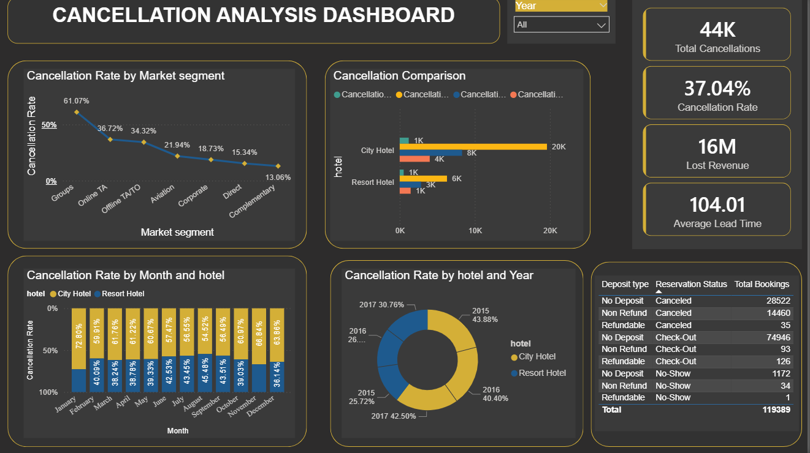
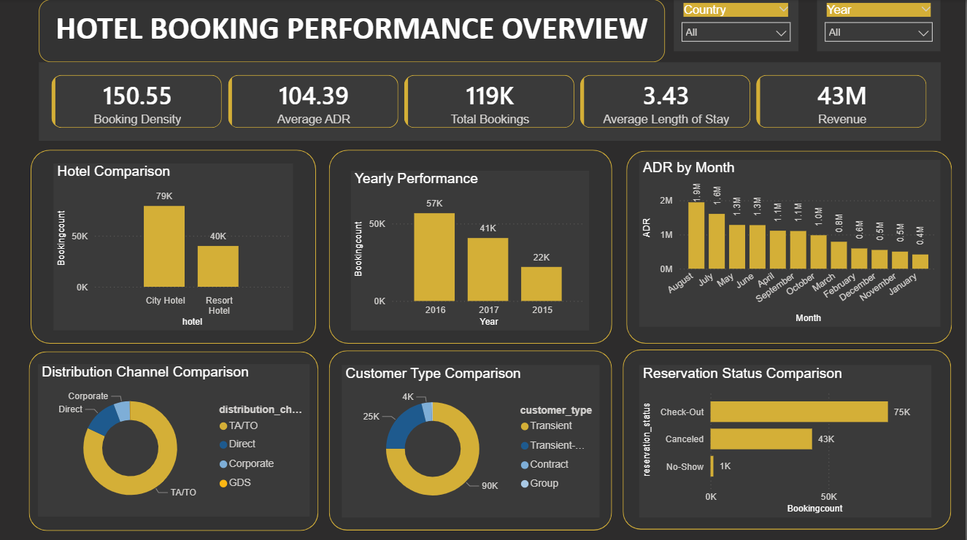
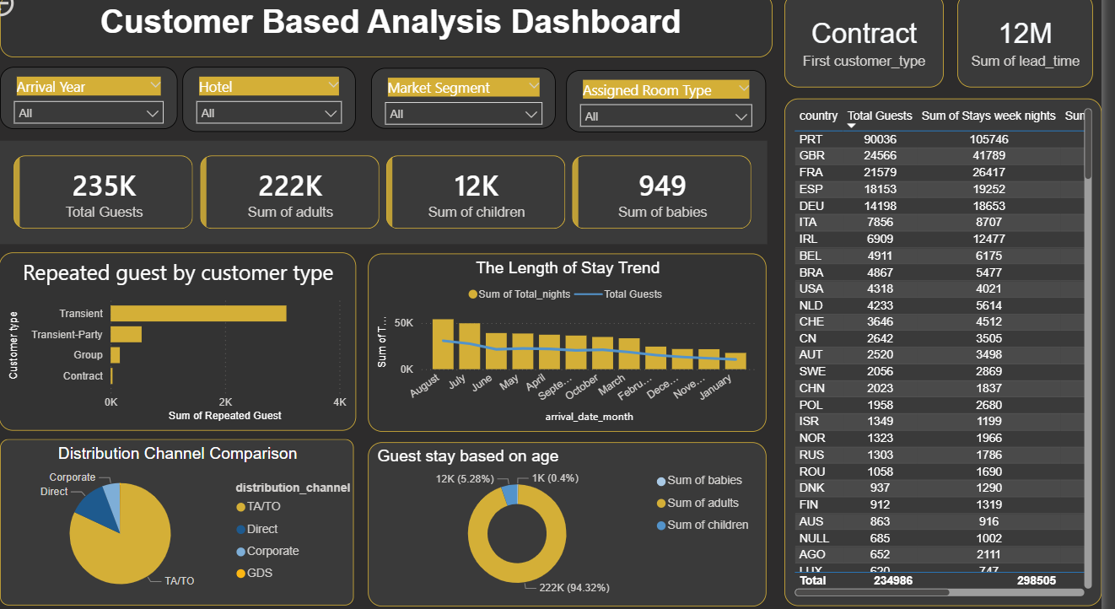
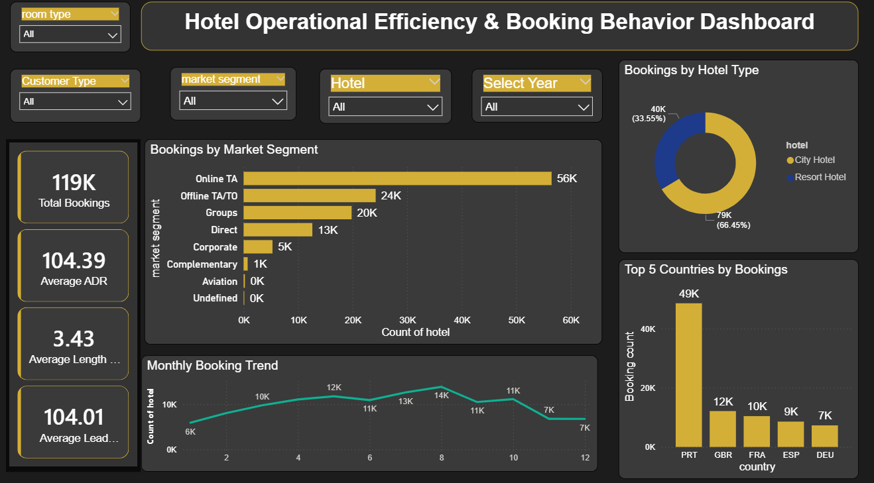

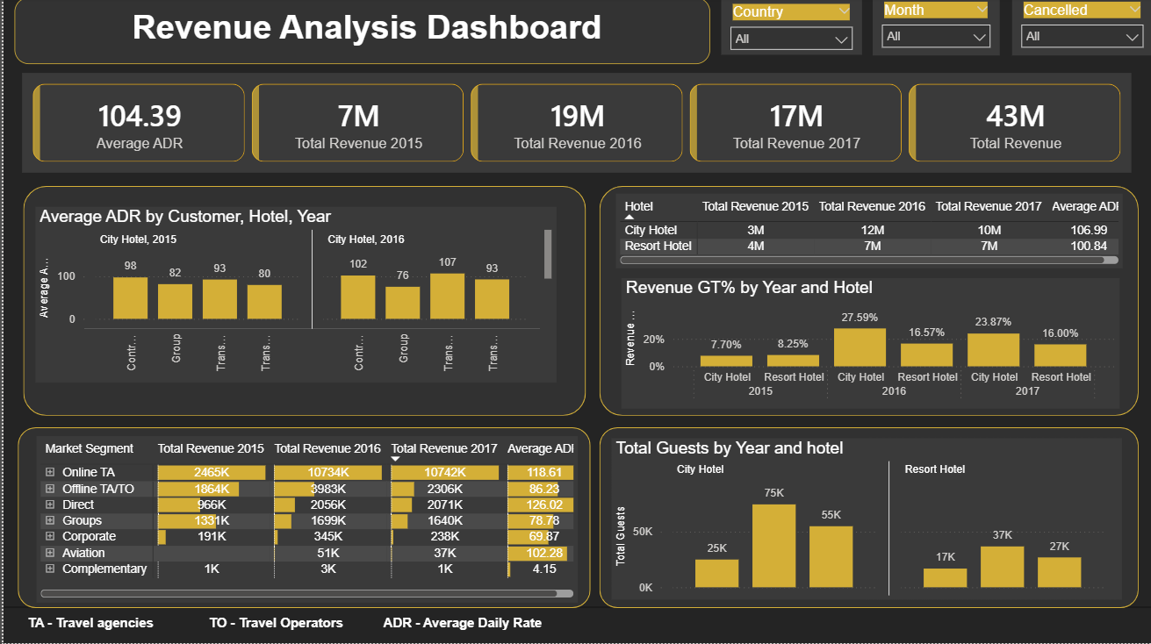

7. Challenges Faced
1. Handling Messy and Missing Data
- The Challenge: Real-world hotel booking datasets are rarely perfect. We found missing information (like blank fields for guest demographics or room preferences) and inconsistent formats (such as different date layouts).
- The Solution: We had to spend a significant amount of time in the data preprocessing phase. We used Python (Pandas) to clean the data, fill in missing values with logical averages, and standardize all text and dates before feeding them to the AI.
2. Imbalanced Data in Cancellation Predictions
- The Challenge: In hotel data, the number of guests who actually complete their stay is usually much higher than those who cancel. Because the data was "imbalanced," our cancellation prediction model initially wanted to guess "not canceled" almost every time.
- The Solution: We had to apply specific machine learning techniques (like adjusting class weights or resampling the data) to force the AI to pay closer attention to the minority of canceled bookings, improving its accuracy.
3. Complex Feature Engineering
- The Challenge: Raw booking dates and room numbers aren't enough for an AI to make smart pricing decisions. The model needed more context to understand human behavior.
- The Solution: We had to brainstorm and engineer new, helpful columns of data. For example, we calculated the "Lead Time" (the number of days between when the guest booked and when they arrived) and created indicators for "Weekend vs. Weekday stays," which drastically improved the model's predictions.
4. Choosing the Right AI Model
- The Challenge: There are dozens of different machine learning algorithms available. Picking the right one that balances high accuracy with fast processing time for real-time dynamic pricing was difficult.
- The Solution: We tested multiple models (such as Random Forest vs. XGBoost) and compared their performance scores to select the most reliable engine for our final dashboard.

5. Virtual Team Coordination
- The Challenge: Collaborating on complex code and data analysis in a remote, virtual internship environment can lead to overlapping work or version control issues.
- The Solution: Maheshbabu Pilli, Thejaswi, and Selciya maintained clear communication, divided specific modules clearly (e.g., one person handling data cleaning while another researched algorithms), and regularly synced up to combine the project files smoothly.

8. Learnings & Skills Acquired
Through the development and execution of the HotelRevAI project, the team gained extensive hands-on experience bridging the gap between raw data and actionable business intelligence. The key learnings and skills acquired span technical proficiency, domain knowledge, and professional collaboration.
1. Technical & Analytical Skills (Hard Skills)
- Advanced Data Preprocessing: Mastered the ability to take messy, real-world hotel booking datasets and clean them for analysis. This included handling missing values, encoding categorical data (like room types and booking channels), and engineering new predictive features (such as 'lead time' and 'stay duration').
- Data Visualization & Storytelling: Acquired the skill to translate complex numerical data into clear visual insights using libraries like Matplotlib and Seaborn, making it easier to identify seasonal booking trends and cancellation patterns.
2. Domain Knowledge (Business Application)
- Hospitality Revenue Management: Developed a deep understanding of hotel economics, specifically how dynamic pricing and demand forecasting are used to maximize RevPAR (Revenue Per Available Room).
- Predictive Business Analytics: Learned how to transition a business from a reactive strategy (responding to empty rooms) to a proactive strategy (predicting cancellations and adjusting prices in real-time to prevent revenue loss).
3. Professional & Soft Skills
- Collaborative Software Development: Improved teamwork and project management skills by dividing complex technical tasks, sharing code, and maintaining consistent communication throughout the project lifecycle.
- Problem-Solving & Troubleshooting: Enhanced the ability to debug code, optimize machine learning models when accuracy was low, and find creative workarounds for data limitations.
- Technical Documentation & Presentation: Refined the ability to document complex system architectures and explain highly technical machine learning concepts in a simple, clear manner for project presentations.

9. Testimonials from team
During this internship, our team had a highly enriching and productive experience working on a real-world data analytics project. The internship provided us with an excellent opportunity to apply our theoretical knowledge in a practical environment while enhancing our technical and analytical skills.
The guidance and support provided by the mentors were extremely valuable throughout the internship. Their clear explanations, continuous support, and constructive feedback helped us understand complex concepts and improve the overall quality of our work.
Our team collaborated effectively during all phases of the project. We actively shared ideas, discussed different approaches, and supported each other in completing tasks. This collaborative environment helped us strengthen our teamwork, communication, and coordination skills.
The structured learning approach of the internship allowed us to progress step by step, starting from understanding the dataset to performing data analysis and creating visualizations. This gradual learning process made it easier for us to grasp concepts and apply them effectively.
Through this experience, we improved our skills in data cleaning, data analysis, and visualization using tools like Power BI. Overall, this internship was a valuable learning journey that helped us gain practical knowledge, enhance problem-solving abilities, and build confidence in handling real-world projects.
10. Conclusion
The HotelRevAI project successfully demonstrates how artificial intelligence can completely transform revenue management in the hospitality industry. By moving away from outdated, fixed pricing models, this project provides a smart, data-driven approach that helps hotels maximize their profits and operational efficiency.
Through the development of machine learning models, we have shown that it is possible to accurately forecast room demand, dynamically adjust prices in real-time, and predict the likelihood of last-minute guest cancellations. These capabilities directly solve major industry challenges: they prevent hotels from underpricing rooms during peak seasons and minimize the financial impact of empty rooms caused by unexpected no-shows.
Ultimately, HotelRevAI empowers hotel administrators to make proactive, profitable decisions rather than just reacting to the market. By turning raw, historical booking data into actionable insights, this AI-driven solution maximizes Revenue Per Available Room (RevPAR) and ensures a more competitive, resilient, and profitable hotel business.

11. Acknowledgements
I would like to express my sincere gratitude to my mentor, Selciya, for her invaluable guidance, continuous support, and constructive feedback throughout the development of the HotelRevAI project. Her technical expertise and encouragement were instrumental in the successful execution of this project.
I am also deeply thankful to the Infosys Springboard team for providing me with the opportunity to participate in the Virtual Internship 6.0 program. This platform has been an exceptional learning experience, allowing me to gain practical exposure to real-world Artificial Intelligence.
Finally, a special note of appreciation goes to the project team members Dodlla Mahesh, Pilli Maheshbabu, Shruti Jain, Harshita, Thejaswi, Nandhini and for their unwavering dedication, collaborative spirit, and technical problem-solving. The successful completion of this AI-driven revenue analysis system is a direct result of our shared teamwork and mutual support throughout every phase of development.

